**TUDA Demo Project Setup environment**

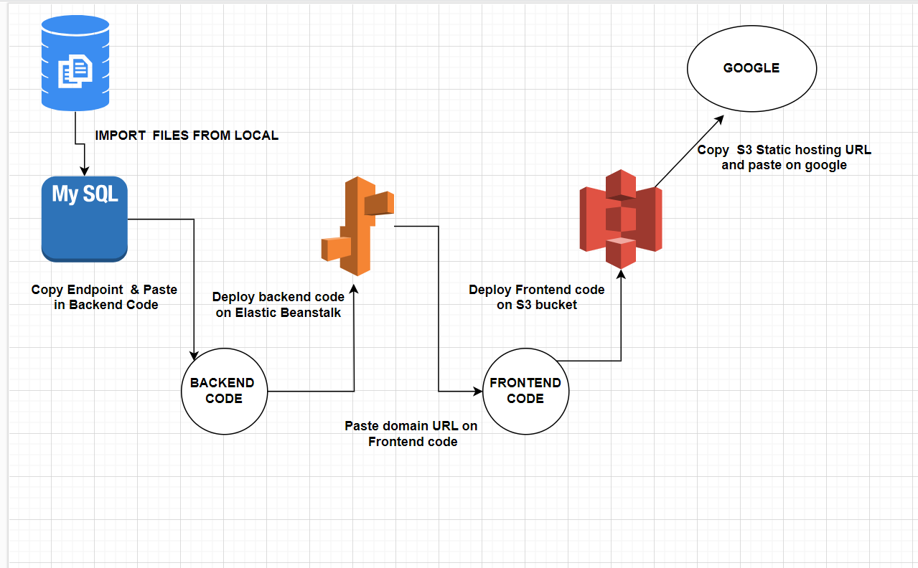

**Requirements for this architecture**

RDS (MySQL)

S3 bucket 2 enabled with static website hosting (admin and user)

Elastic Beanstalk

RDS (MySQL)

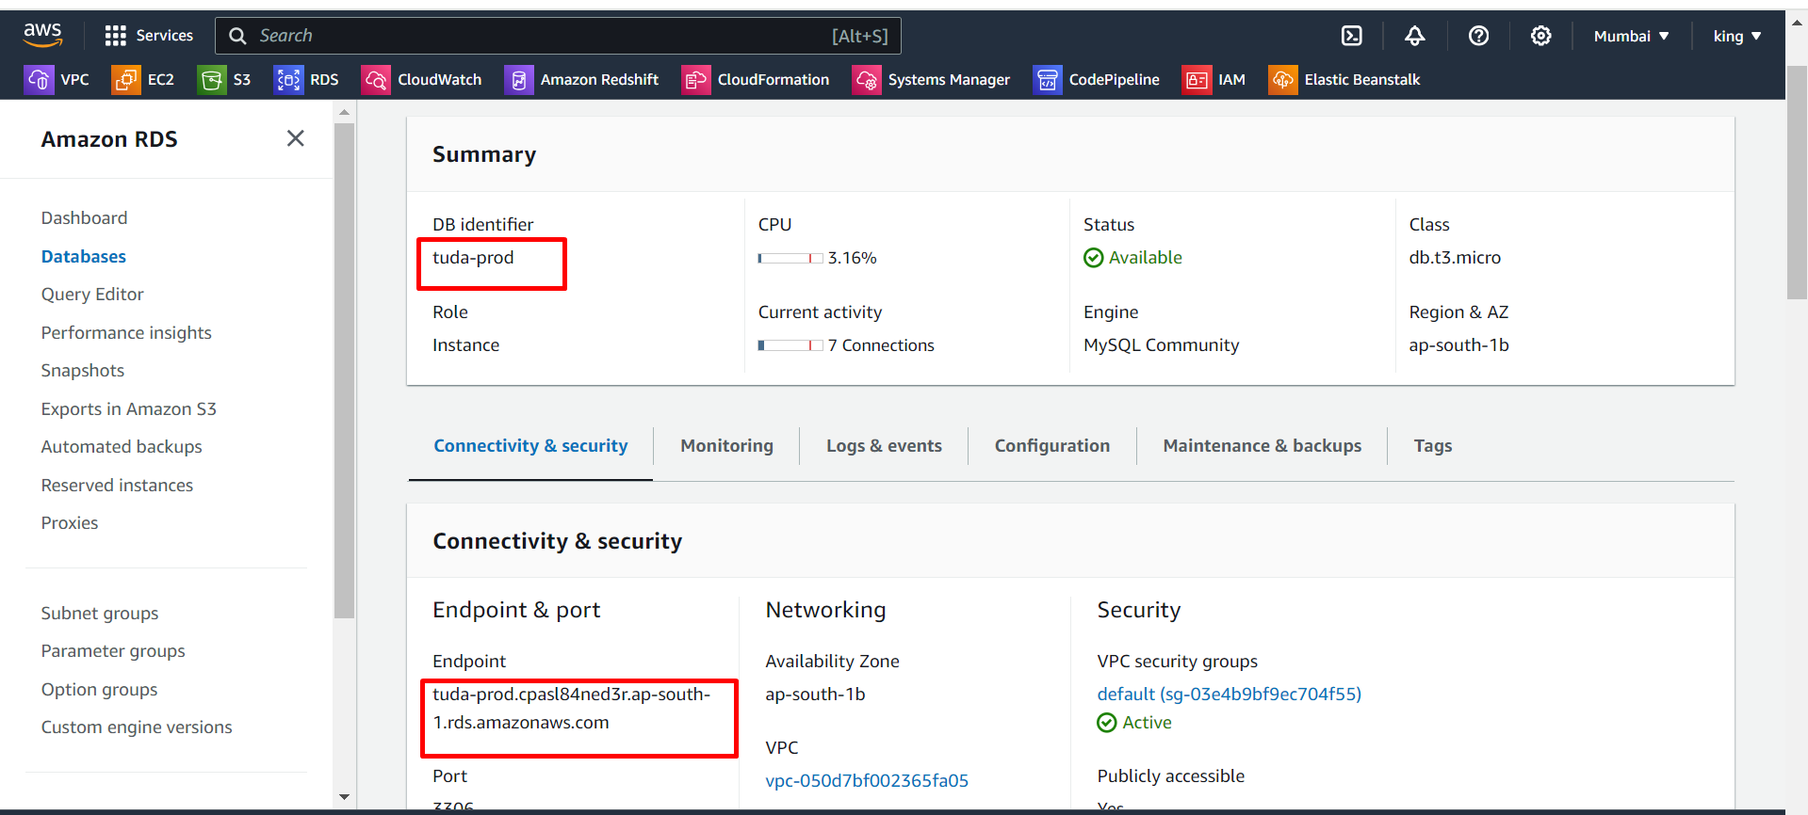

After creating the MySQL database connect that database to the MySQL workbench

With the help of the endpoint of the database.

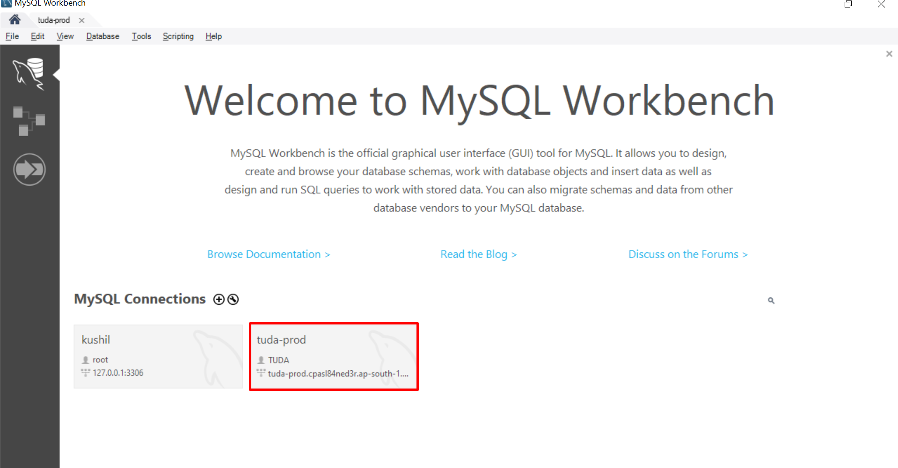

Next, we import data from the local to the MySQL database.

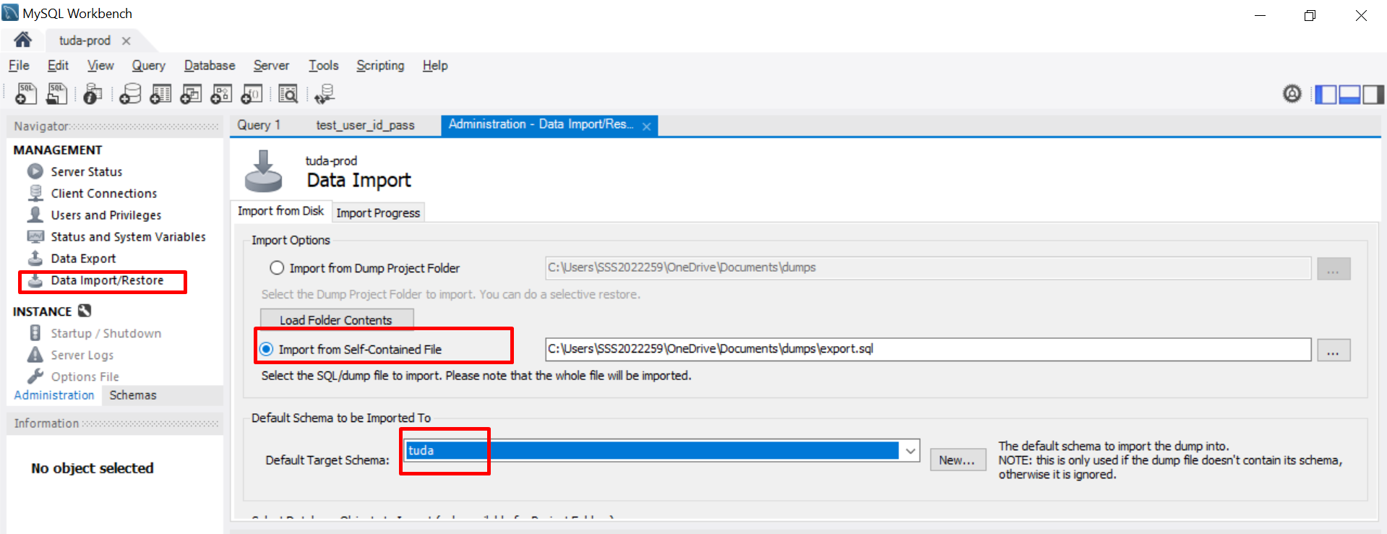

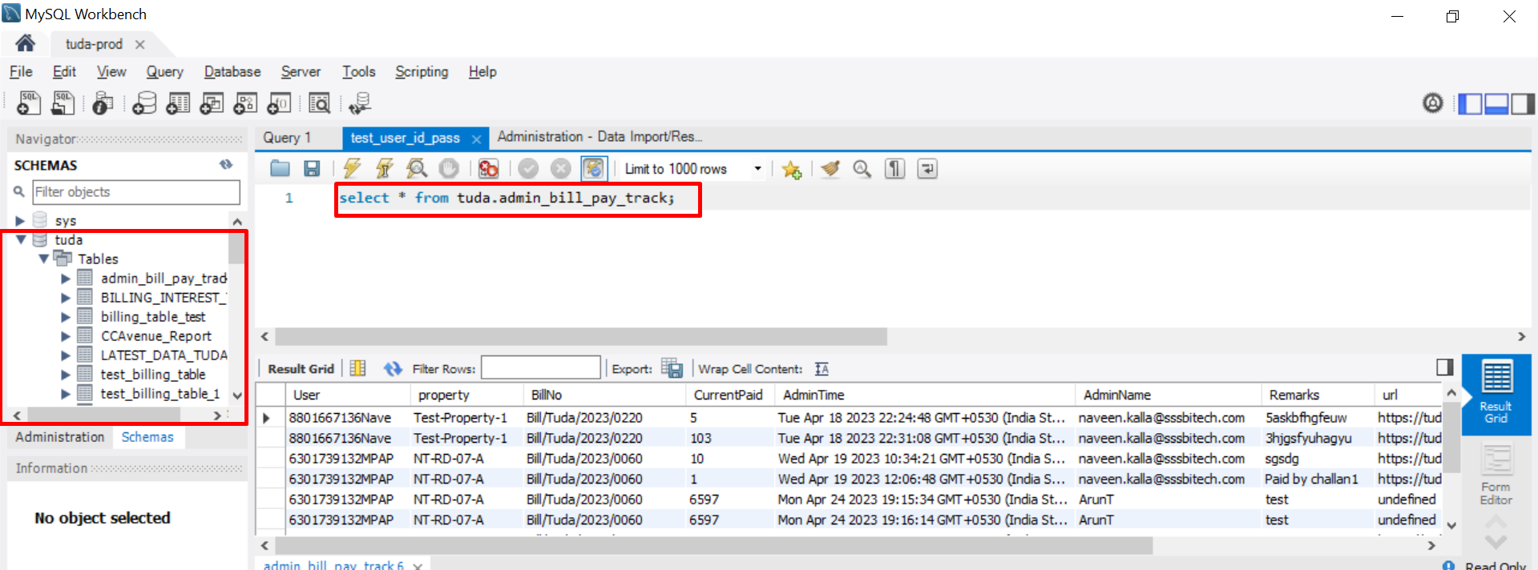

Next, we copy that database endpoint and paste on backend code (app.js)

Next, we create elastic beanstalk.

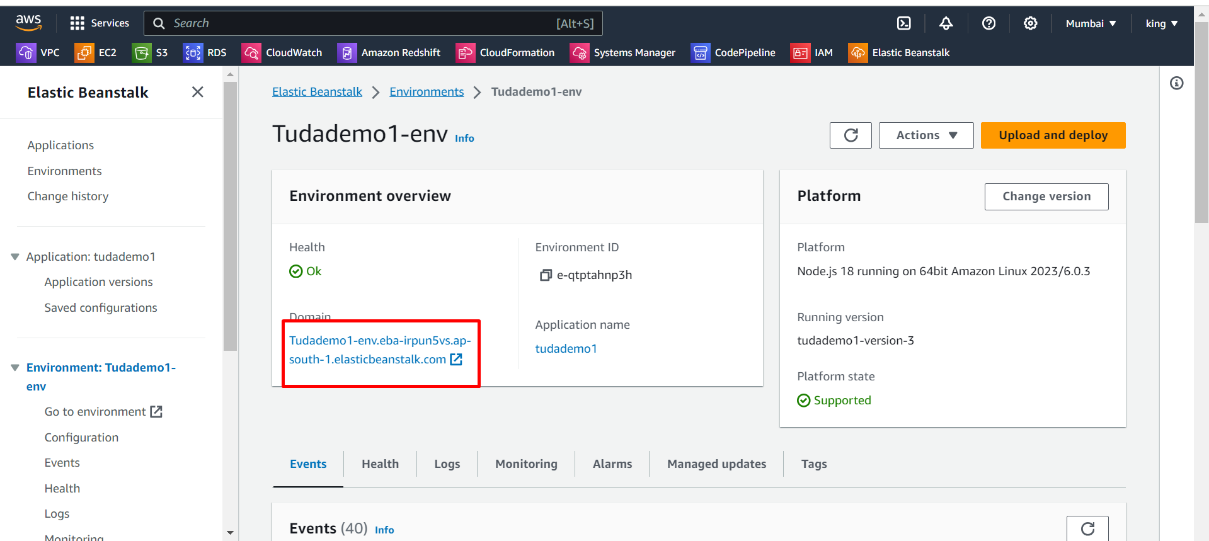

Next, deploy the backend code on Elastic Beanstalk

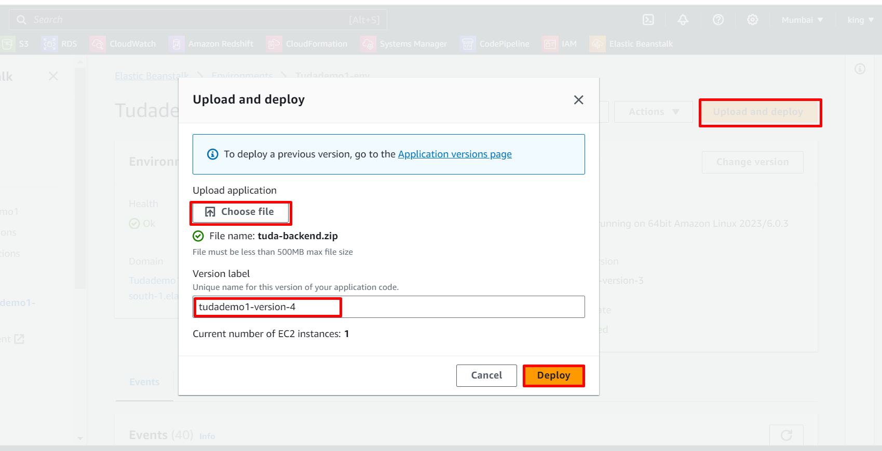

Next, we copy the domain URL of the elastic beanstalk and paste it on Google we get this type of error. This means we are doing the correct process.

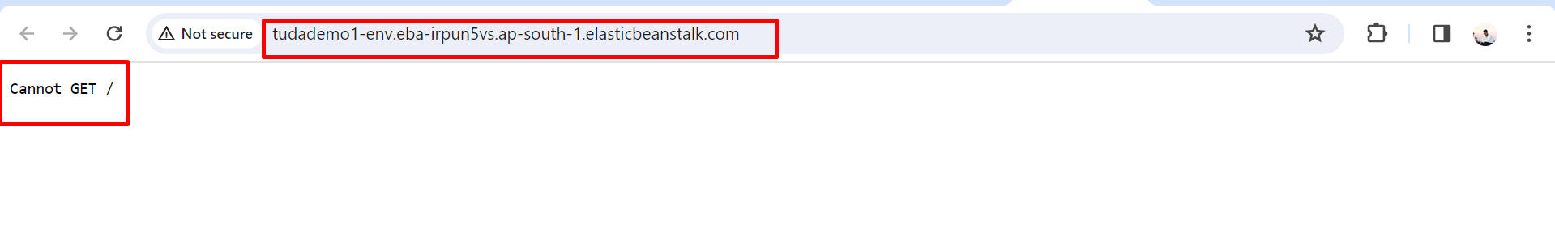

Next, we copy the domain URL and send it to the application team, and they paste that URL on the frontend code. After that application team sends frontend build files to us.

This is the front-end code sent by the application team in this process.

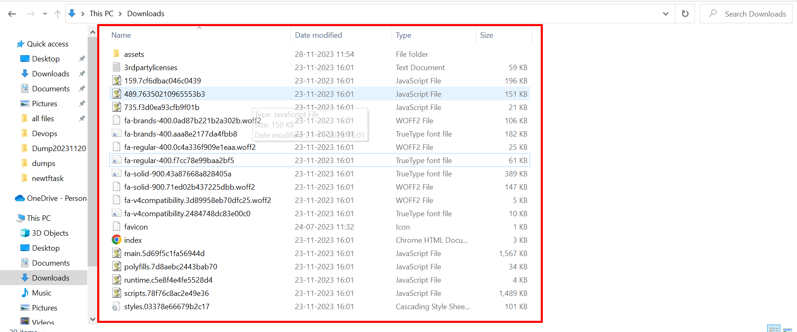

Now we are deploying this code on an s3 bucket.

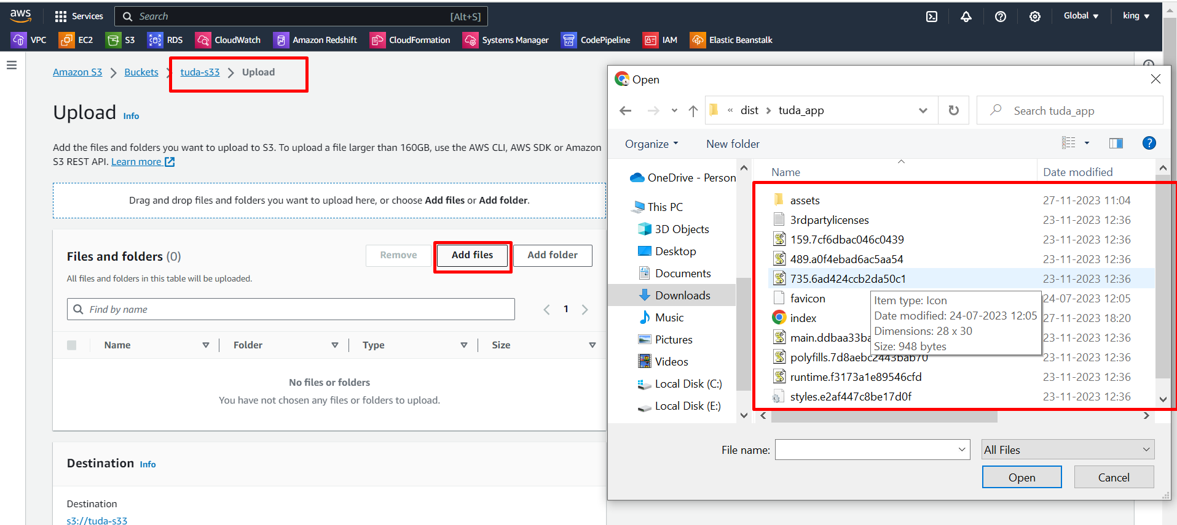

We successfully deployed the TUDA demo application on the s3 bucket.

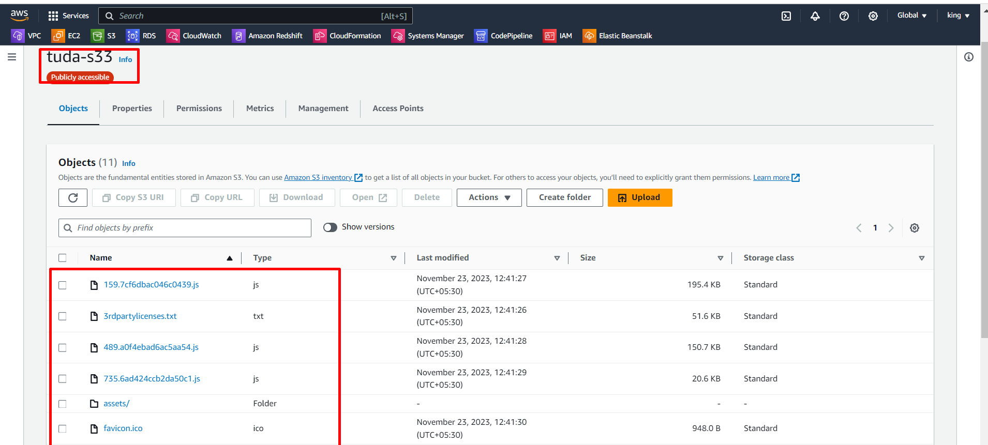

Next, we go to the properties of the s3 bucket.

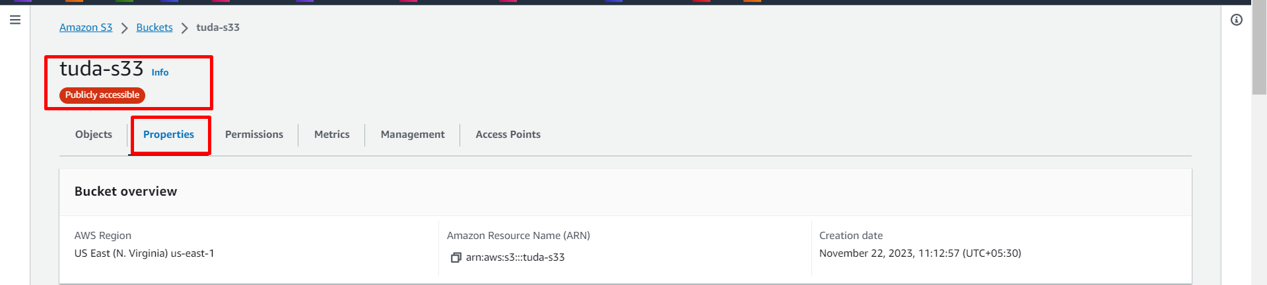

Next, click on the static website hosting URL.

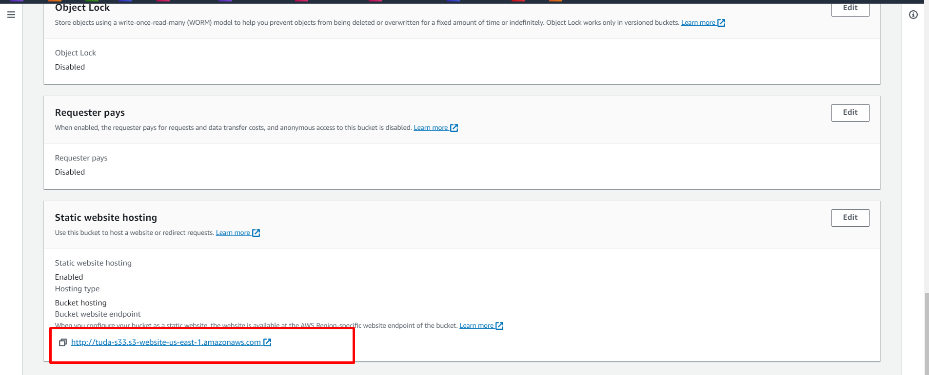

We successfully deployed the TUDA application.

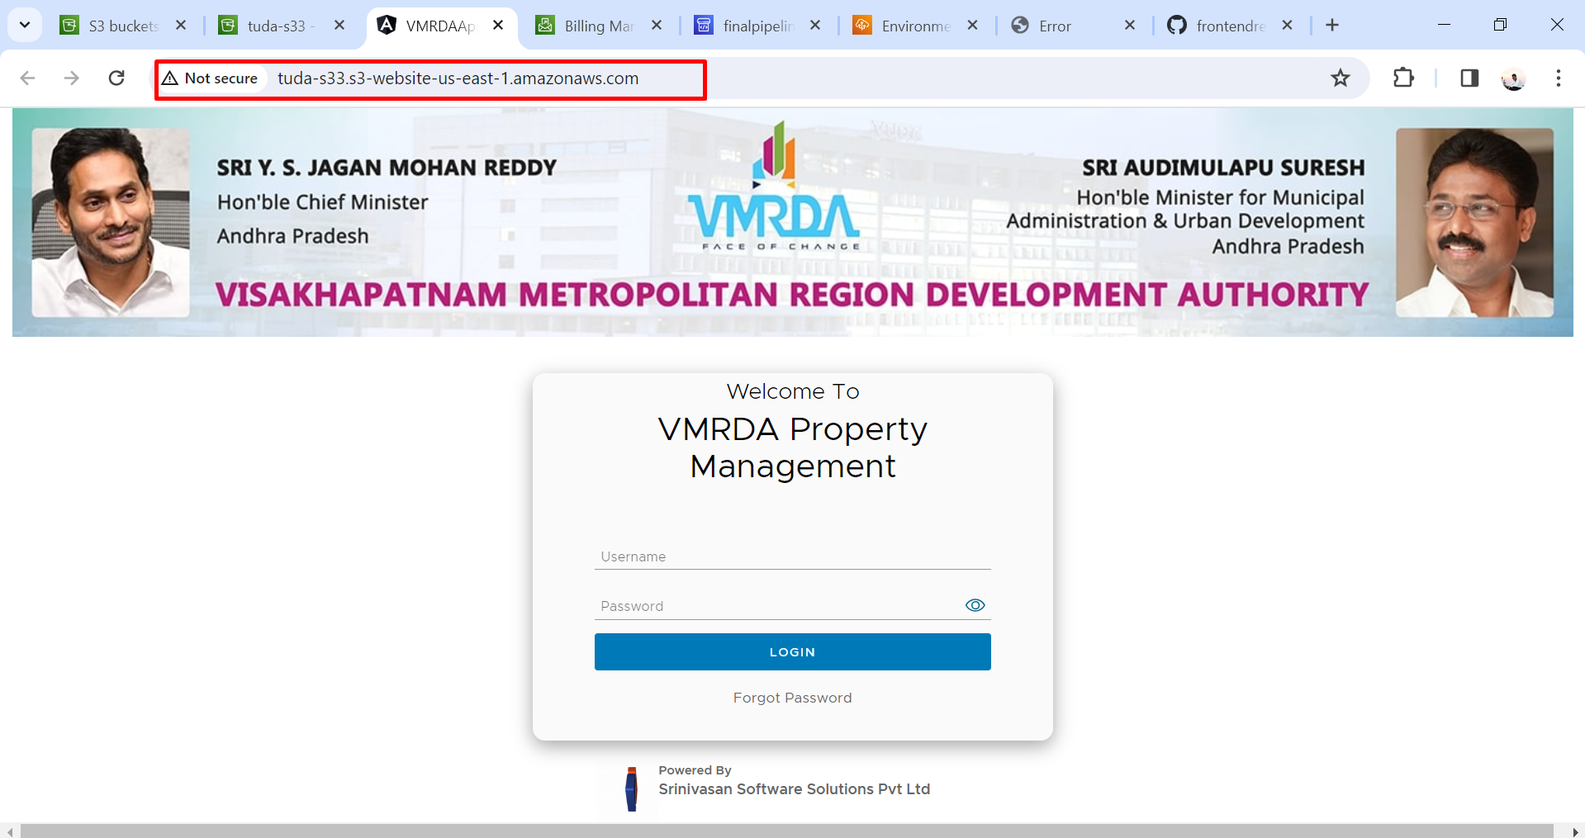

Now we enter a username and password.

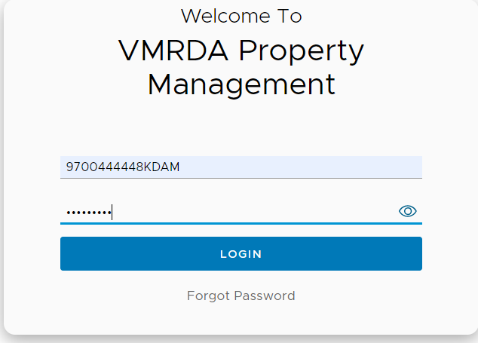

We successfully logged in TUDA demo web application.

This is a user credentials application.

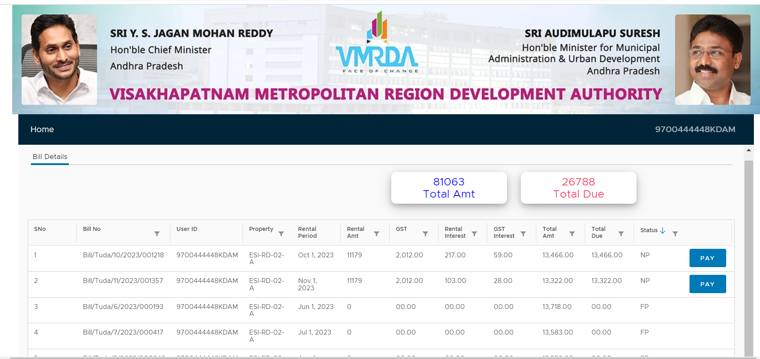

Now we deploy the admin application on a different s3 bucket.

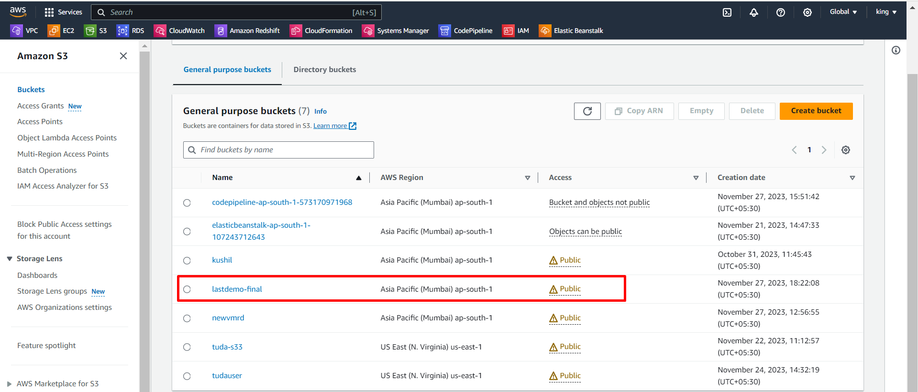

Next, we deploy the admin frontend code here.

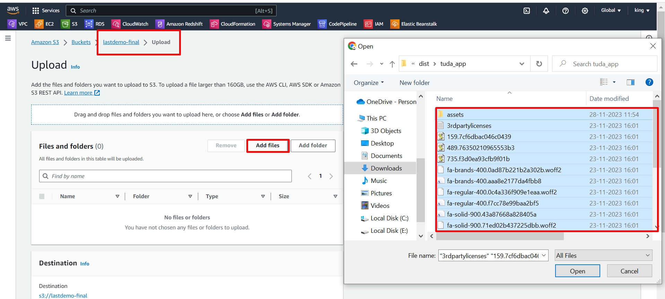

Upload code successfully.

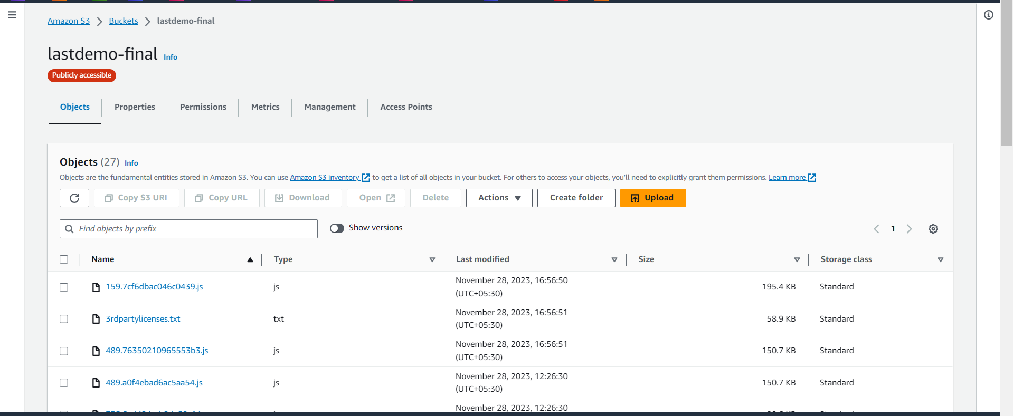

Now go to properties of s3 bucket and click on static website hosting URL. 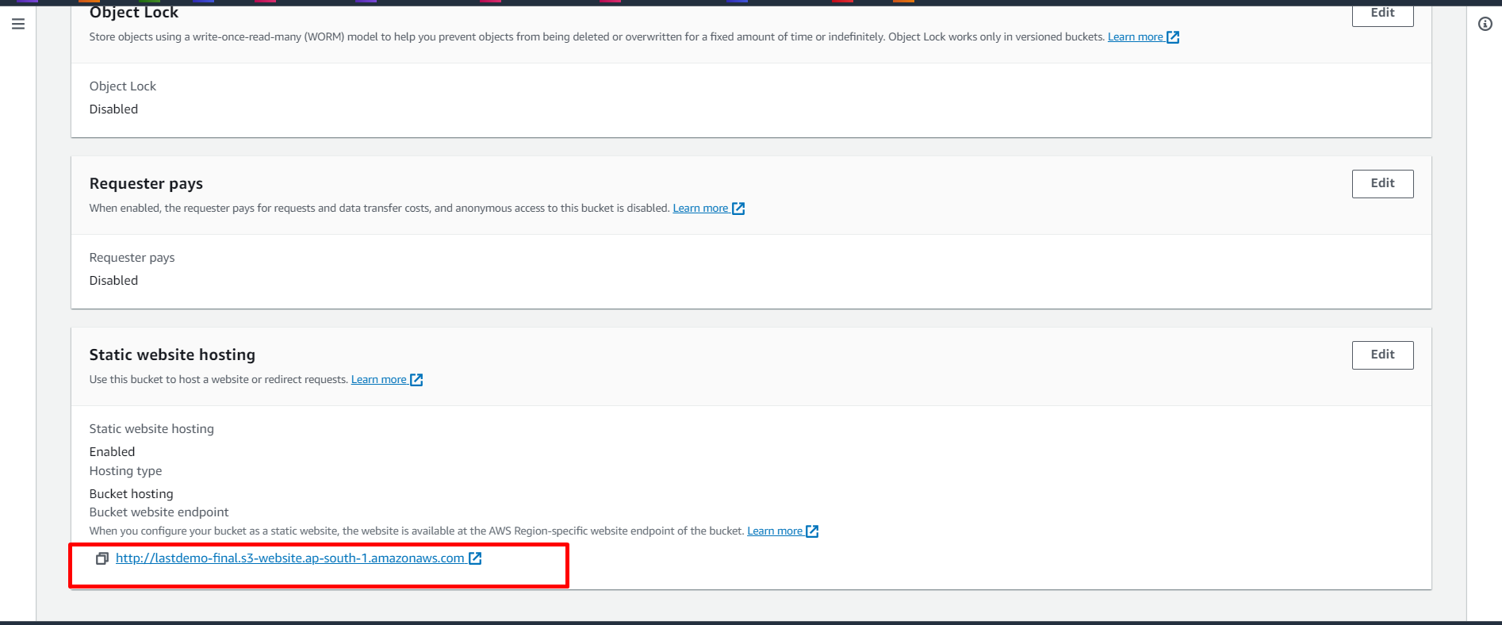

We successfully deploy the application.

But here I gave user credentials in this admin application, it shows invalid credentials because it is an admin application.

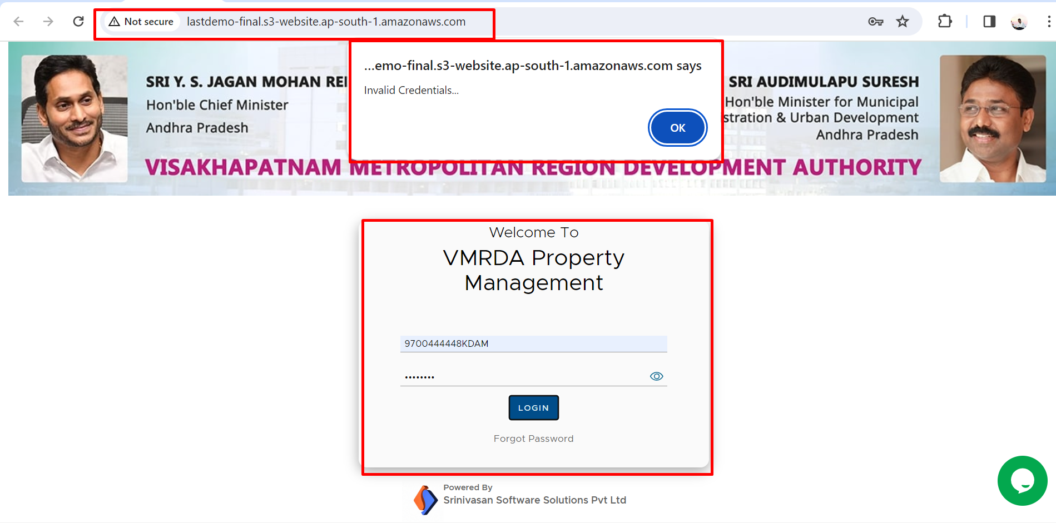

Now we gave admin credentials it asking OTP for that.

